**CSCE 560 Homework / Wireshark Lab 1**

**Chapter 1 – Computer Networks and the Internet**

**Fall 18**

**Marvin Newlin**

**Assigned: Monday, 1 Oct**

**Due: Monday, 15 Oct, 1400**

**Problem 1.**  Chapter 1, P6

This elementary problem begins to explore propagation delay and transmission delay, two central concepts in data networking. Consider two hosts, A and B, connected by a single link of rate *R* bps. Suppose that the two hosts are separated by *m* meters, and suppose the propagation speed along the link is *s* meters/sec. Host A is to send a packet of size *L* bits to Host B.

* 1. Express the propagation delay, *dprop*, in terms of *m* and *s*.

**Sol’n:** d­prop is a measurement of time. Time = distance/speed. Thus,

dprop = *m*/*s*

* 1. Determine the transmission time of the packet, *dtrans*, in terms of *L* and *R*.

**Sol’n:** Again, dtrans is a measurement of time so we measure the size of the file/rate we can transmit file. Thus,

drans = *L*/*R*

* 1. Ignoring processing and queuing delays, obtain an expression for the end-to-end delay.

**Sol’n:** To totally measure delay from end to end we have to account for the time it takes to transmit and the time it takes to propagate. Thus, an expression for end-end delay is

dtotal = dtrans + dprop

* 1. Suppose Host A begins to transmit the packet at time *t* = 0. At time *t* = *dtrans*, where is the last bit of the packet?

**Sol’n:** Since we measure dtrans as *L*/*R*, at time t = dtrans we have just completed transmitting the entire file. Thus, at time t = dtrans, the last bit of the file has just been placed on the wire to propagate.

* 1. Suppose *dprop* is greater than *dtrans*. At time *t* = *dtrans*, where is the first bit of the packet?

**Sol’n:** At time t = dtrans with dprop > dtrans, the first bit has been transmitted and is propagating through the wire. The exact location of the first bit in terms of *s* is (dprop – dtrans)\**s*

* 1. Suppose *dprop* is less than *dtrans*. At time *t* = *dtrans*, where is the first bit of the packet?

**Sol’n:** At time t = dtrans, if dprop < dtrans, then the first bit has completed propagating and has been received at the other end.

* 1. Suppose *s* = 2.5 x 108, *L* = 120 bits, and *R* = 56 kbps. Find the distance *m* so that *dprop* equals *dtrans*.

**Sol’n:**

We know that dprop = *m/s* and we know that dtrans = *L/R*. Thus, to find *m* such that dprop = dtrans we do,

*m/s = L/R 🡪 m = Ls/R 🡪 m* = (2.5*108 m/s)*(120 bits)/(56*103 bps) 🡪 *m* = 535.7 km

**Problem 2.** Chapter 1, P7

In this problem, we consider sending real-time voice from Host A to Host B over a packet-switched network (VoIP). Host A converts analog voice to a digital 64 kbps bit stream on the fly. Host A then groups the bits into 56-byte packets. There is one link between Host A and B; its transmission rate is 2 Mbps and its propagation delay is 10 msec. As soon as Host A gathers a packet, it sends it to Host B. As soon as Host B receives an entire packet, it converts the packet's bits to an analog signal. [Assume the conversion of the digital signal back to analog takes 0 seconds.] How much time elapses from the time a bit is created (from the original analog signal at Host A) until the bit is decoded (as part of the analog signal at Host B)?

**Sol’n:**

The total delay can be broken down into 4 sections. dconv is the first part where the conversion from analog to digital takes place. The second part is dtrans, the amount of time it takes to transmit a 56 byte packet at Host A. The third part is dprop, the time it takes for a bit to travel from A to B. The 4th part is the delay for the conversion from digital back to analog. This is assumed to be zero. Thus the total delay is

dtotal = dconv + dtrans + dprop

dconv = time it takes for packet to be created = 64kbps/56*8bits/packet = 1/142 sec/packet or approx. 7 msec.

dtrans = packet size / data rate = 56*8 bits / 2*106 bps = 224 msec

dprop = 10 msec and is given in the problem

Thus, the time for the total delay is

dtotal = 7 msec + 224 msec + 10 msec = 241 msec

**Problem 3.** Chapter 1, P25

Suppose two hosts, A and B, are separated by 20,000 kilometers and are connected by direct link of *R* = 2 Mbps. Suppose the propagation speed over the link is 2.5 x 108 meters/sec. Assume the protocol does not require acknowledgements.

* 1. Calculate the bandwidth-delay product, *R* x *dprop*.

**Sol’n:**

dprop = *distance/speed* = (20*106) m / (2.5*108 m/sec) = 0.08 sec

*R* x *dprop* = 2*106 bps * 0.08 sec = 160*103 bits = 160 Kbits

* 1. Consider sending a file of 800,000 bits from Host A to Host B. Suppose the file is sent continuously as one big message. What is the maximum number of bits that will be in the link at any given time?

**Sol’n:**

The maximum number of bits that can be in the link at any given time is given by the bandwidth-delay product so the maximum number is 1.6*105 bits.

* 1. Provide an interpretation of the bandwidth-delay product [for this scenario as well as if acknowledgements were required].

**Sol’n:**

The bandwidth-delay product is like the throughput of the file. It tells me how much I can fit into the pipe at one given time.

* 1. What is the width (in meters) of a bit in the link? Is it longer than a football field?

**Sol’n:**

To determine the width of a single bit we multiply the speed of the bit by the time it takes to transmit the bit. Thus, w = 1/R*s So

w = 1/(2*106 bits/sec) * (2.5*108 m/sec) = 125 m/bit. Since a football field is 100 yards and 1 meter is bigger than 1 yard, the bit is indeed larger than a football field.

* 1. Derive a general expression for the width of a bit in terms of the propagation speed *s*, the transmission rate *R*, and the length of the link *m*.

**Sol’n:**

From above we have that lbit­ = (1/R bps) * (s m/sec) = s/R m/bit

**Problem 4.**  Chapter 1, P26

Referring to problem 25, suppose we can modify R. For what value of R is the width of a bit as long as the length of the link?

**Sol’n:**

From problem 3e we have that the width of the bit is equal to s/R so to make s/R = 20*106 meters we simply divide s by the link length to determine the bit rate we want.

s/R = 20*106 meters 🡪 s/20*106 meters = R 🡪 R = (2.5 x 108 meters/sec)/20*106 meters = 12.5 bits/sec

**Problem 5.**  Chapter 1, P27

Consider problem 25 but now with a link of R = 1 Gbps.

1. Calculate the bandwidth-delay product, R x dprop.

**Sol’n:**

The elements that determine dprop remain unchanged so it is still 0.08 sec

delay-bandwidth = R*dprop = 109 bps * 8*10-2 sec = 8*107 bits = 80Mbits

1. Consider sending a file of 800,000 bits from Host A to Host B. Suppose the file is sent continuously as one big message. What is the maximum number of bits that will be in the link at any given time?

**Sol’n:**

Our file size is 800Kbits and our delay-bandwidth product is 80Mbits. This means that we can fit the whole file onto the pipe at once so the maximum number of bits on the link will be 800Kbits.

1. What is the width (in meters) of a bit in the link?

**Sol’n:**

From our general determination, a single bit is s/R meters long so

*l*bit = (2.5*108 m/sec)/(109 bits/sec) = 0.25 meters

**Problem 6.**  Chapter 1, P28

Refer again to problem 25.

1. How long does it take before the entire file is received at the destination assuming it is sent continuously?

**Sol’n:**

Assuming continuous transmission we can transmit the entire file in dtrans +(file size/delay-bandwidth product)* dprop time. We have to multiply the propagation time by the file size/delay-bw product because we can’t fit the whole file on the wire at once.

File size/delay-bw = 800,000 bits / 160,000 bits = 5

dtrans = 800000 bits / 2Mbps = 0.4 sec

dprop = 20,000 km/ 2.5*108 m/s = 0.08 sec

dtotal = 0.4 sec + 5(0.08) = 0.4 + 0.4 = 0.8 sec

1. Suppose now the file is broken up into 20 packets with each packet containing 40,000 bits. Suppose that each packet is acknowledged by the receiver and the transmission time of an acknowledgment packet is negligible. Finally, assume that the sender cannot send a packet until the preceding one is acknowledged. How long does it take to send the file?

**Sol’n:**

For each packet we have a total time of dtrans + 2*dprop (since we have to wait for acknowledgement)

dtrans = 40000/2*106 = 0.02 sec

Thus, the total time is

dtotal = 20*(0.02 + 2*0.08 sec) = 3.6 sec

**Problem 7.**  Chapter 1, P29

Suppose there is a 10 Mbps microwave link between a geostationary satellite [36 x 106 meters above Earth] and its base station on Earth. Every minute the satellite takes a digital photo and sends it to the base station. Assume a propagation speed of 2.4 x 108 meters/sec. Also assume acknowledgements are not required.

1. What is the propagation delay of the link?

**Sol’n:**

dprop = 36*106 m / (2.4*108 m/sec) = 0.15 sec

1. What is the bandwidth-delay product, R x dprop?

**Sol’n:**

R x dprop = 107 bps * 0.15 sec = 1.5 Mbits

1. Let x denote the size of the photo. What is the minimum value of x for the microwave link to be continuously transmitting?

**Sol’n:**

In order to be continuously transmitting, we need to “fill up the pipe” which means reaching the delay bandwidth product. Thus, our file size should be at least 1.5 Mbits in order to continuously transmit.

**Problem 8.** Chapter 1, P31

In modern packet-switched networks, including the Internet, the source host segments long, application-layer messages (for example, an image or a music file) into smaller packets and sends the packets into the network. The receiver then reassembles the packets back into the original message. We refer to this process as message segmentation. Figure 1.27 illustrates the end-to-end transport of a message with and without message segmentation. Consider a message that is 8 x 106 bits long that is to be sent from source to destination in Figure 1.27. Suppose each link in the figure is 2 Mbps. Ignore propagation, queuing, and processing delays.

1. Consider sending the message from source to destination *without* message segmentation. How long does it take to move the message from the source host to the first packet switch? Keeping in mind that each switch uses store-and-forward packet switching, what is the total time to move the message from source host to destination host?

**Sol’n:**

Assuming we do not segment, our time to transmit from source to the first packet switch is

File Size/Data Rate = (8*106 bits)/(2*106bits/sec) = 4 seconds.

With this transmission technique, the time needed to complete the transmission of the file is 3 transmission times since we are transmitting the file in 3 places. Thus, the transmission time is

3 * dtrans= 3 * 4 sec = 12 seconds

1. Now suppose that the message is segmented into 800 packets, with each packet being 10,000 bits long. How long does it take to move the first packet from source host to the first switch? When the first packet is being sent from the first switch to the second switch, the second packet is being sent from the source host to the first switch. At what time will the second packet be fully received at the first switch?

**Sol’n:**

Now, with segmentation, our dtrans for a single packet is given by

dtrans = 104 bits /(2*106) bits/sec = 0.005 sec

The first packet reaches the second switch at 2*dtrans and at this point the second packet is at the first switch. Thus, with one more transmission time, the second packet will arrive at the second switch. Thus, the time for the second packet to reach the second switch is 3*dtrans = 0.015 sec

1. How long does it take to move the file from source host to destination host when message segmentation is used? Compare this result with your answer in part (a) and comment.

**Sol’n:**

As per the slides, we can break this down into Transmission delay and Forwarding delay. The transmission delay is simply the number of packets times the transmission time and the forwarding delay is simply the number of hops between the source and destination times the transmission time. Thus, the total time is

dtrans total = number of packets * dtrans + Number of switches*dtrans

dtotal = 800*dtrans + 2*dtrans = 802*0.005 sec = 4.01 sec

This is a drastic decrease in the amount of time it takes to send the file because we are able to efficiently send the packets, i.e. we get as close to mimicking send the file directly from source to destination rather than going through 2 switches. If we do not segment, large parts of the file are just sitting around waiting to be sent because of the bottleneck on the bandwidth-delay product.

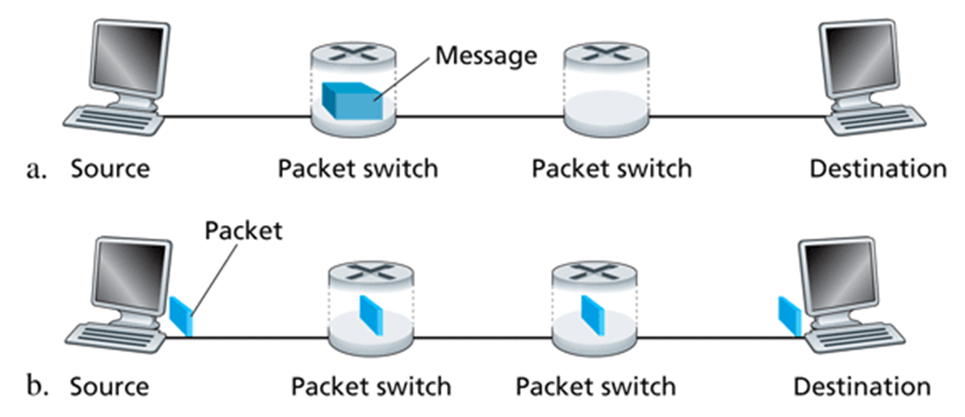

**Problem 9.** History of Networking Video

Watch the video Modern Marvels Wiring America.mp4 from 32:00 minutes to the end (44:18). Indicate on your homework solution that you actually watched the video.

I have watched the video.

**Wireshark Lab**

Complete the lab in 01 - Wireshark_Intro.pdf.